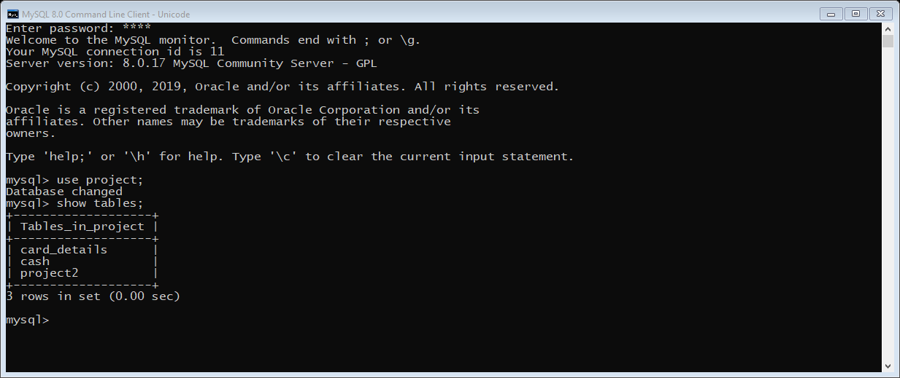

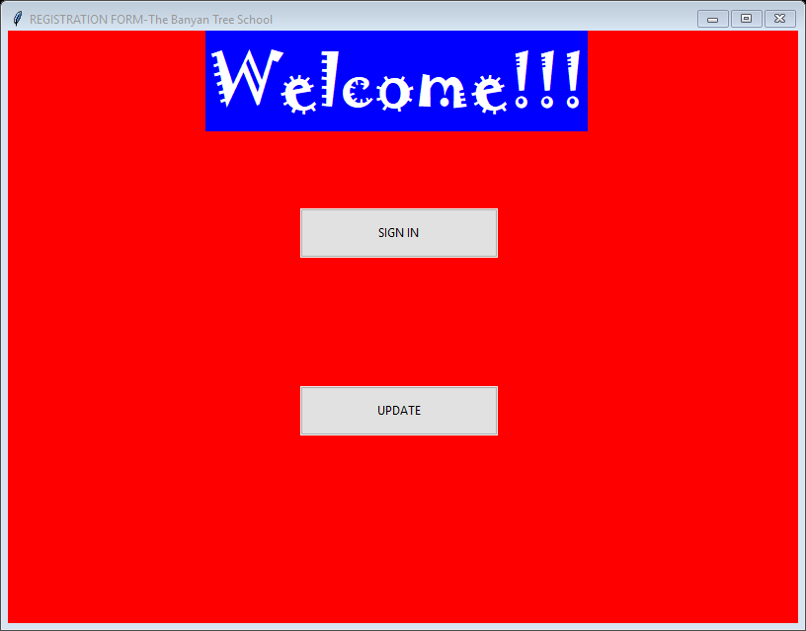

**from** tkinter **import *  
import** mysql.connector **as** sq  
**from** tkinter.ttk **import *  
from** tkinter **import** font  
**from** subprocess **import** call  
os1**=**Tk**()**os1.title**("REGISTRATION FORM-The Banyan Tree School")**os1.configure**(**background**="red")**os1.geometry**('800x500')**os1.maxsize**(**800,600**)**os1.minsize**(**800,600**)**a2**=**Label**(**os1,text**="Welcome!!!"**,background**='blue'**,foreground**="white"**,font**="Jokerman 50")**a2.place**(**relx**=**0.25**)  
  
def login():** call**(["python"**,**"login.py"])**a3**=**Button**(**os1,text**="SIGN IN"**,command**=**login**)**.place**(**relx**=**0.37,rely**=**0.3,height**=**50,width**=**200**)  
  
def login():** call**(["python"**,**"loginupdate.py"])**a4**=**Button**(**os1,text**="UPDATE"**,command**=**login**)**a4.place**(**relx**=**0.37,rely**=**0.6,height**=**50,width**=**200**)**os1.mainloop**()**

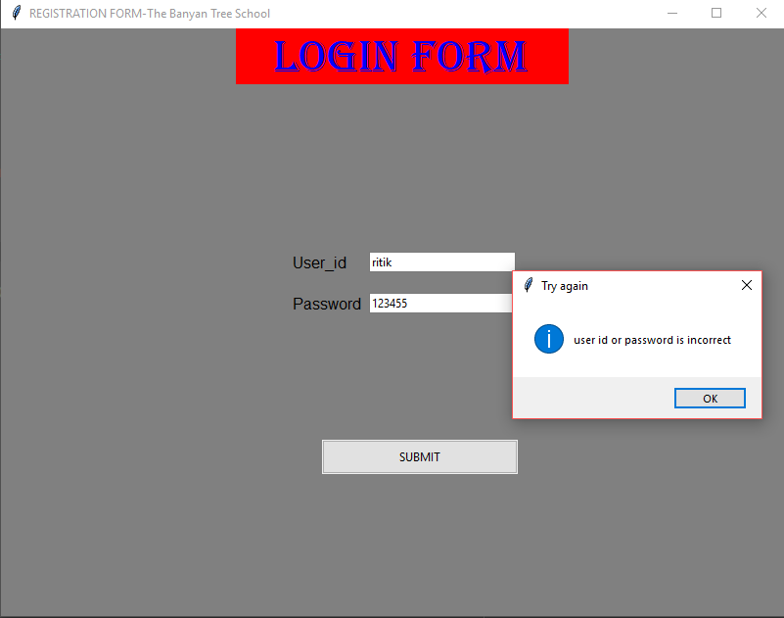

**import** mysql.connector **as** sq  
**from** tkinter **import *  
from** tkinter.ttk **import *  
import** tkinter.messagebox  
**from** subprocess **import** call  
  
os2**=**Tk**()**os2.title**("REGISTRATION FORM-The Banyan Tree School")**os2.geometry**('800x500')**os2.maxsize**(**800,600**)**os2.minsize**(**800,600**)**os2.configure**(**background**="grey")**a1**=**StringVar**()**b1**=**StringVar**()**head1**=**Label**(**os2,text**=" LOGIN FORM"**, background**="RED"**, font**="algerian 35"**, foreground**="BLUE"**,width**=**12**)**head1.place**(**relx**=**0.30**)**a **=** Label**(**os2,text**="User_id"**, width**=**30, background**="grey"**,font**="bold")**.place**(**relx**=**0.37,rely**=**0.38**)**Entry**(**os2,textvariable**=**a1**)**.place**(**relx**=**0.47,rely**=**0.38,width**=**150**)**b **=** Label**(**os2,text**="Password"**, width**=**30, background**="grey"**,font**="bold")**.place**(**relx**=**0.37,rely**=**0.45**)**Entry**(**os2,textvariable**=**b1**)**.place**(**relx**=**0.47,rely**=**0.45,width**=**150**)  
  
def login():** mycon **=** sq.connect**(**host**="localhost"**,database**="project"**,user**="root"**,passwd**="root")** cur **=** mycon.cursor**()**

**if (**a1.get**()=='ritik' and** b1.get**()=='12345'):** call**(["python"**, **"registration.py"])  
 else:** tkinter.messagebox.showinfo**("Try again"**,**"user id or password is incorrect")**d **=** Button**(**os2, text**="SUBMIT"**, command**=**login**)**d.place**(**relx**=**0.41,rely**=**0.70,height**=**35,width**=**200**)**os2.mainloop**()**

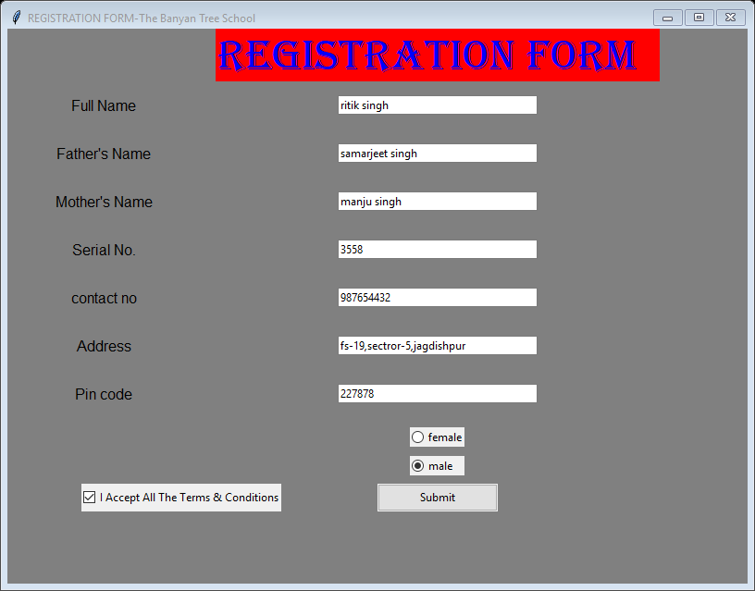

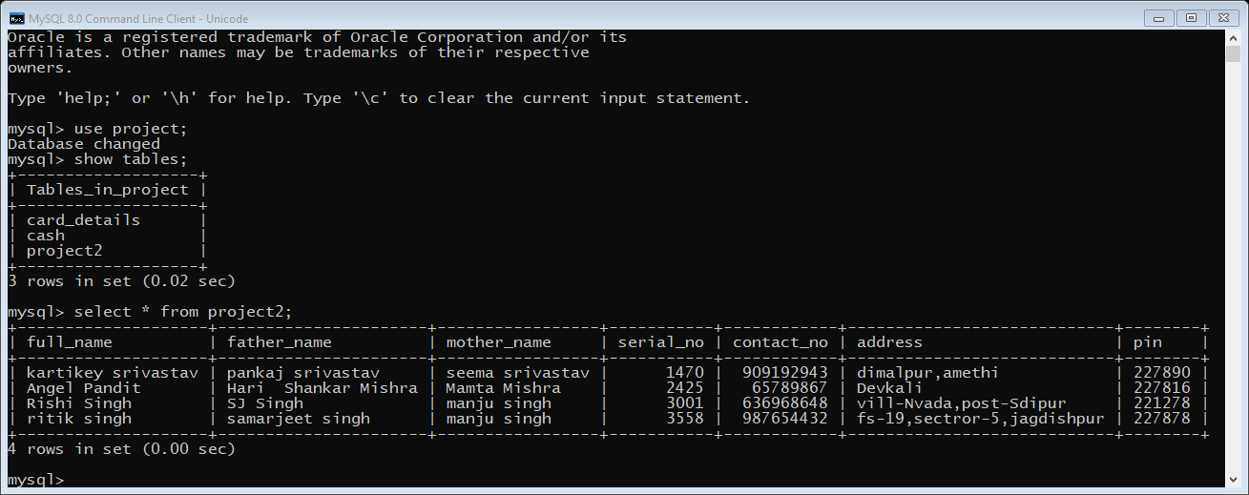

**import** mysql.connector **as** sqltor  
**from** tkinter **import *  
from** tkinter.ttk **import *  
from** subprocess **import** call  
  
os**=**Tk**()**os.title**("REGISTRATION FORM-The Banyan Tree School")**os.geometry**("800x500")**os.configure**(**background**="grey")**os.maxsize**(**800,600**)**os.minsize**(**800,600**)**f_name **=** StringVar**()**fs_name**=**StringVar**()**ms_name**=**StringVar**()**sr_no**=**StringVar**()**con_no**=**StringVar**()**add**=**StringVar**()**pin**=**StringVar**()  
  
def hk():** mycon**=**sqltor.connect**(**host**="localhost"**,user**="root"**,passwd**="root"**,database**="project")** cursor**=**mycon.cursor**()** cursor.execute**("insert into project2 values('"+**f_name.get**()+"','"+**fs_name.get**()+"','"+**ms_name.get**()+"','"+**sr_no.get**()+"','"+**con_no.get**()+"','"+**add.get**()+"','"+**pin.get**()+"')")** mycon.commit**()** call**(["python"**, **"payment mode.py"])**label1**=**Label**(**os,text**="Registration form"**,background**="RED"**,width**="17"**,font**="algerian 35"**,foreground**="BLUE")**label2**=**Label**(**os,text**="Full Name"**,background**="grey"**,foreground**='black'**,font**="bold")**label3**=**Label**(**os,text**="Father's Name"**,background**='grey'**,foreground**='black'**,font**="bold")**label4**=**Label**(**os,text**="Mother's Name"**,background**='grey'**,foreground**='black'**,font**="bold")**label5**=**Label**(**os,text**="Serial No."**,background**='grey'**,foreground**='black'**,font**="bold")**label6**=**Label**(**os,text**="contact no"**,background**="grey"**,foreground**='black'**,font**="bold")**label7**=**Label**(**os,text**="Address"**,background**="grey"**,foreground**='black'**,font**="bold")**label8**=**Label**(**os,text**="Pin code"**,background**="grey"**,foreground**='black'**,font**="bold")**bu1 **=**Checkbutton**(**os,text**="I Accept All The Terms & Conditions")**bu2 **=**Button**(**os,text**="Submit"**,command**=**hk,width**="20")**gen1**=**Radiobutton**(**os,text**='female'**,value**=**1,width**="6")**gen2**=**Radiobutton**(**os,text**='male'**,value**=**2,width**="6")**user2**=**Entry**(**os,width**="35"**,textvariable**=**f_name**)**user3**=**Entry**(**os,width**="35"**,textvariable**=**fs_name**)**user4**=**Entry**(**os,width**="35"**,textvariable**=**ms_name**)**user5**=**Entry**(**os,width**="35"**,textvariable**=**sr_no**)**user6**=**Entry**(**os,width**="35"**,textvariable**=**con_no**)**user7**=**Entry**(**os,width**="35"**,textvariable**=**add**)**user8**=**Entry**(**os,width**="35"**,textvariable**=**pin**)**label1.grid**(**row**=**0,column**=**1,pady**=**0,padx**=**16**)**label2.grid**(**row**=**1,column**=**0,pady**=**15,padx**=**25**)**label3.grid**(**row**=**2,column**=**0,pady**=**15,padx**=**50**)**label4.grid**(**row**=**3,column**=**0,pady**=**15,padx**=**50**)**label5.grid**(**row**=**4,column**=**0,pady**=**15,padx**=**50**)**label6.grid**(**row**=**5,column**=**0,pady**=**15,padx**=**50**)**label7.grid**(**row**=**6,column**=**0,pady**=**15,padx**=**50**)**label8.grid**(**row**=**7,column**=**0,pady**=**15,padx**=**50**)**bu1.place**(**relx**=**0.10,rely**=**0.82,height**=**30**)**bu2.place**(**relx**=**0.50,rely**=**0.82,height**=**30**)**gen1.grid**(**row**=**9,column**=**1,pady**=**10**)**gen2.grid**(**row**=**10,column**=**1**)**user2.grid**(**row**=**1,column**=**1**)**user3.grid**(**row**=**2,column**=**1**)**user4.grid**(**row**=**3,column**=**1**)**user5.grid**(**row**=**4,column**=**1**)**user6.grid**(**row**=**5,column**=**1**)**user7.grid**(**row**=**6,column**=**1**)**user8.grid**(**row**=**7,column**=**1**)**os.mainloop**()**

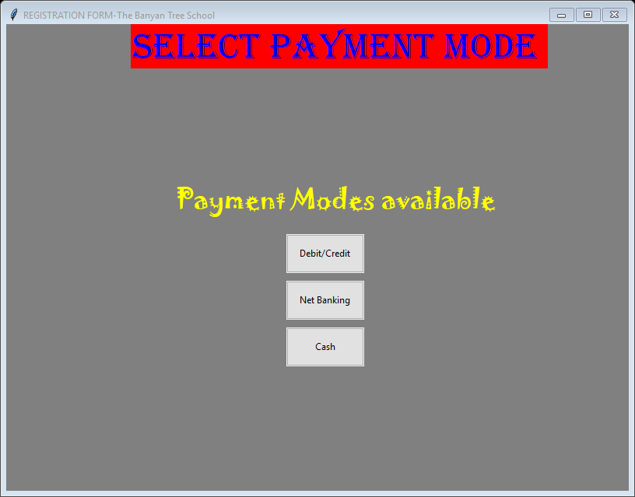

**from** tkinter **import *  
from** tkinter.ttk **import *  
from** subprocess **import** call  
os4**=**Tk**()**os4.title**("REGISTRATION FORM-The Banyan Tree School")**os4.geometry**("800x500")**os4.maxsize**(**800,600**)**os4.minsize**(**800,600**)**os4.config**(**background**="grey")**label1**=**Label**(**os4,text**="Select payment mode"**,background**="RED"**,width**="19"**,font**="algerian 35"**,foreground**="blue")**label2**=**Label**(**os4,text**="Payment Modes available"**,background**="grey"**,font**="jokerman 25"**,foreground**="yellow")  
def deb_crd():** call**(["python"**,**"card detail.py"])**bu1 **=** Button**(**os4,text **="Debit/Credit"**,width**=**15,command**=**deb_crd**)**bu3 **=** Button**(**os4,text **="Net Banking"**,width**=**15**)  
  
def cash():** call**(["python"**,**"payment.py"])**bu4 **=** Button**(**os4,text **="Cash"**,width**=**15,command**=**cash**)**label1.place**(**relx**=**0.20**)**label2.place**(**relx**=**0.27,rely**=**0.33**)**bu1.place**(**relx**=**0.45,rely**=**0.45,width**=**100,height**=**50**)**#bu2.grid(row=4,column=0,pady =4)  
bu3.place**(**relx**=**0.45,rely**=**0.55,width**=**100,height**=**50**)**bu4.place**(**relx**=**0.45,rely**=**0.65,width**=**100,height**=**50**)**os4.mainloop**()**

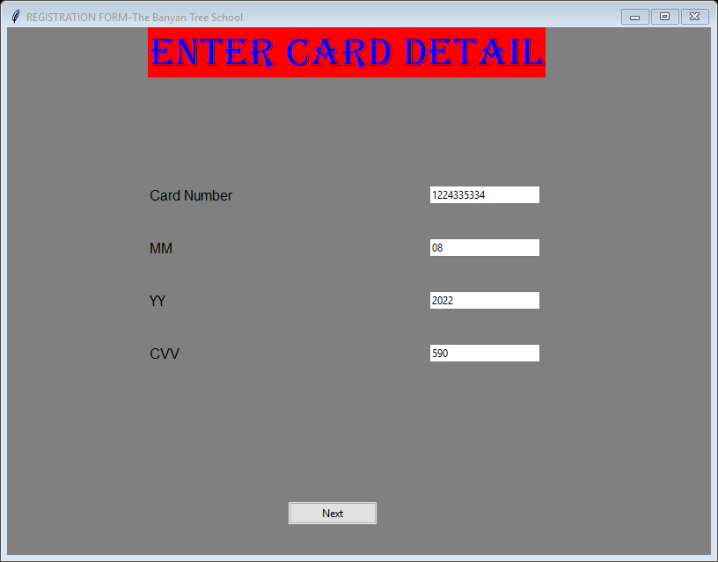

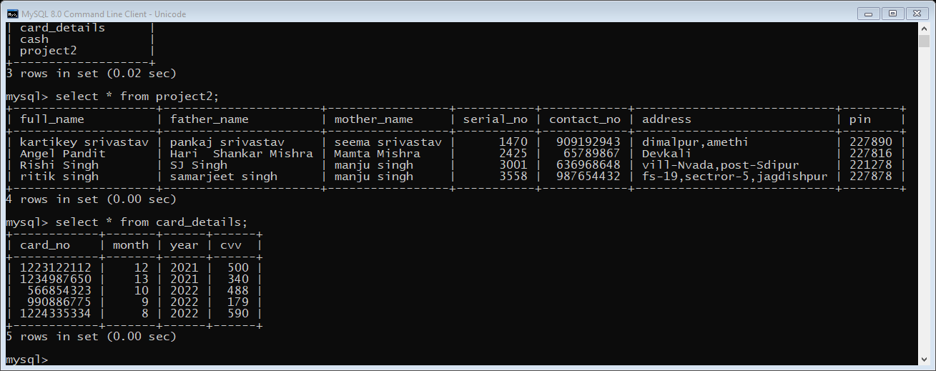

**from** tkinter **import *  
from** tkinter.ttk **import *  
import** mysql.connector **as** sqltor  
**from** subprocess **import** call  
  
os5**=**Tk**()**os5.title**("REGISTRATION FORM-The Banyan Tree School")**os5.geometry**('800x500')**os5.maxsize**(**800,600**)**os5.minsize**(**800,600**)**os5.configure**(**background**="grey")**#a0=StringVar()  
card_no**=**StringVar**()**month**=**StringVar**()**year**=**StringVar**()**cvv**=**StringVar**()**Amount**=**StringVar**()**label0**=**Label**(**os5,text**="Enter card detail"**,foreground**="blue"**,font**="Algerian 35"**,background**='red')**label1**=**Label**(**os5,text**="Card Number"**,background**="grey"**,font**="bold")**label2**=**Label**(**os5,text**="MM"**,background**="grey"**,font**="bold")**label3**=**Label**(**os5,text**="YY"**,background**="grey"**,font**="bold")**label4**=**Label**(**os5,text**="CVV"**,background**="grey"**,font**="bold")  
  
def pay():** mycon **=** sqltor.connect**(**host**="localhost"**, user**="root"**, passwd**="root"**, database**="project")** cursor **=** mycon.cursor**()** cursor.execute**("insert into card_details values('" +**card_no.get**()+ "','" +**month.get**()+ "','" +**year.get**()+ "','" +**cvv.get**()+ "')")** mycon.commit**()** call**(["python"**,**"payment.py"])**bu1 **=** Button**(**os5,text **="Next"**, width**=**15,command**=**pay**)**e1 **=** Entry**(**os5,textvariable**=**card_no**)**e2 **=** Entry**(**os5,textvariable**=**month**)**e3 **=** Entry**(**os5,textvariable**=**year**)**e4 **=** Entry**(**os5,textvariable**=**cvv**)**label0.place**(**relx**=**0.2,rely**=**0**)**label1.place**(**relx**=**0.2,rely**=**0.3**)**label2.place**(**relx**=**0.2,rely**=**0.4**)**label3.place**(**relx**=**0.2,rely**=**0.5**)**label4.place**(**relx**=**0.2,rely**=**0.6**)**bu1.place**(**relx**=**0.4,rely**=**0.9**)**e1.place**(**relx**=**0.6,rely**=**0.3**)**e2.place**(**relx**=**0.6,rely**=**0.4**)**e3.place**(**relx**=**0.6,rely**=**0.5**)**e4.place**(**relx**=**0.6,rely**=**0.6**)**os5.mainloop**()**

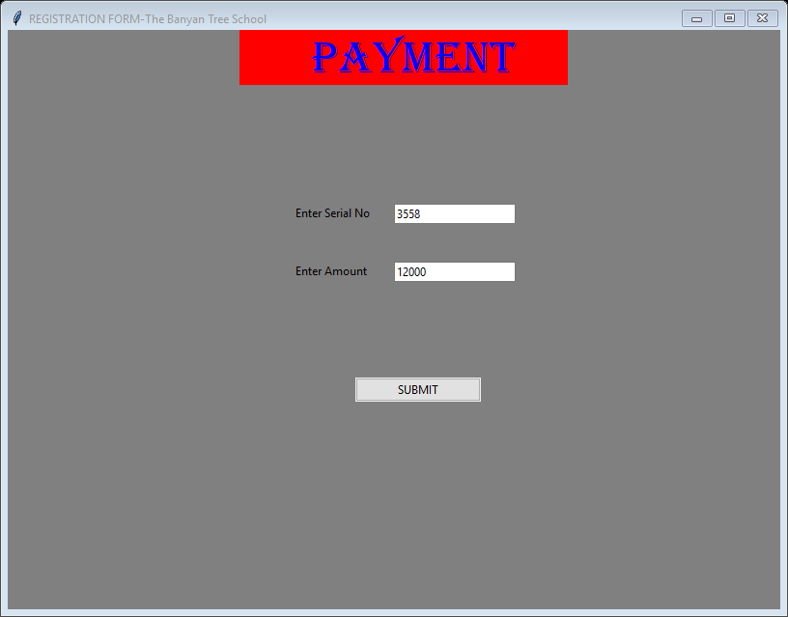

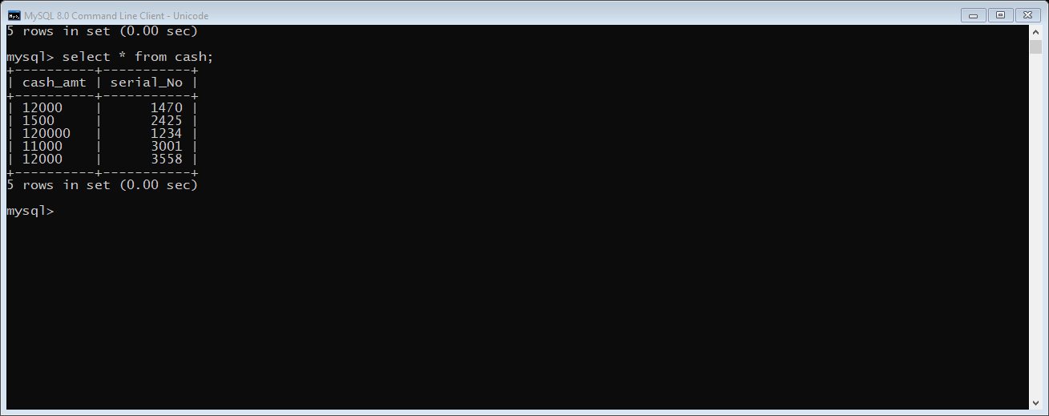

**from** tkinter **import *  
import** mysql.connector **as** sqltor  
**from** tkinter.ttk **import *  
from** subprocess **import** call  
  
os7**=**Tk**()**os7.title**("REGISTRATION FORM-The Banyan Tree School")**os7.geometry**("800x500")**os7.configure**(**background**="grey")**os7.maxsize**(**800,600**)**os7.minsize**(**800,600**)**cash_amt**=**StringVar**()**Serial_no**=**StringVar**()**head1**=**Label**(**os7,text**=" PAYMENT"**, background**="RED"**, font**="algerian 35"**, foreground**="BLUE"**,width**=**12**)**head1.place**(**relx**=**0.30**)**label1**=**Label**(**os7,text**="Enter Serial No"**,background**="grey"**,foreground**="black")**.place**(**relx**=**0.37,rely**=**0.3**)**label2**=**Label**(**os7,text**="Enter Amount"**,background**="grey"**,foreground**="black")**.place**(**relx**=**0.37,rely**=**0.4**)**l1**=**Entry**(**os7,textvariable**=**cash_amt**)**.place**(**relx**=**0.5,rely**=**0.3**)**l2**=**Entry**(**os7,textvariable**=**Serial_no**)**.place**(**relx**=**0.5,rely**=**0.4**)  
def sub():** mycon **=** sqltor.connect**(**host**="localhost"**, database**="project"**, user**="root"**, passwd**="root")** cur **=** mycon.cursor**()** cur.execute**("insert into cash values('"+**Serial_no.get**()+"','"+**cash_amt.get**()+"')")** mycon.commit**()** call**(["python"**,**"successful.py"])**bu1**=**Button**(**os7,text**="SUBMIT"**,command**=**sub,width**="20")**bu1.place**(**relx**=**0.45,rely**=**0.6**)**os7.mainloop**()**

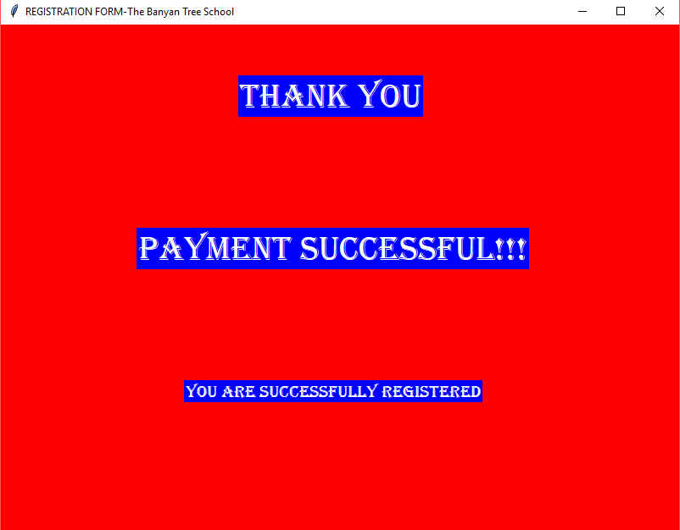

**from** tkinter **import *  
from** tkinter.ttk **import \***os6**=**Tk**()**os6.title**("REGISTRATION FORM-The Banyan Tree School")**os6.geometry**("800x500")**os6.configure**(**background**="RED")**os6.maxsize**(**800,600**)**os6.minsize**(**800,600**)**label1**=**Label**(**os6,text**="Thank You"**,background**='blue'**,foreground**="white"**,font**="Algerian 30")**label2**=**Label**(**os6,text**="Payment Successful!!!"**,background**='blue'**,foreground**="white"**,font**="Algerian 30")**label3**=**Label**(**os6,text**="You are successfully Registered"**,background**='blue'**,foreground**="white"**,font**="Algerian 15")**label1.place**(**relx**=**0.35,rely**=**0.1**)**label2.place**(**relx**=**0.2,rely**=**0.4**)**label3.place**(**relx**=**0.27,rely**=**0.7**)**os6.mainloop**()**

***TO UPDATE DATA***

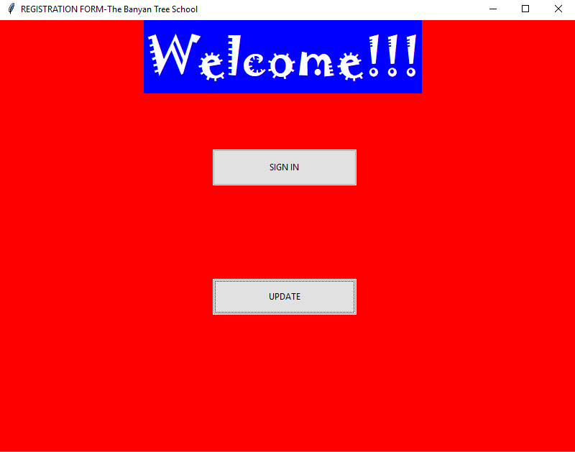

**from** tkinter **import *  
import** mysql.connector **as** sq  
**from** tkinter.ttk **import *  
from** tkinter **import** font  
**from** subprocess **import** call  
os1**=**Tk**()**os1.title**("REGISTRATION FORM-The Banyan Tree School")**os1.configure**(**background**="red")**os1.geometry**('800x500')**os1.maxsize**(**800,600**)**os1.minsize**(**800,600**)**a2**=**Label**(**os1,text**="Welcome!!!"**,background**='blue'**,foreground**="white"**,font**="Jokerman 50")**a2.place**(**relx**=**0.25**)  
  
def login():** call**(["python"**,**"login.py"])**a3**=**Button**(**os1,text**="SIGN IN"**,command**=**login**)**.place**(**relx**=**0.37,rely**=**0.3,height**=**50,width**=**200**)  
  
def login():** call**(["python"**,**"loginupdate.py"])**a4**=**Button**(**os1,text**="UPDATE"**,command**=**login**)**a4.place**(**relx**=**0.37,rely**=**0.6,height**=**50,width**=**200**)**os1.mainloop**()**

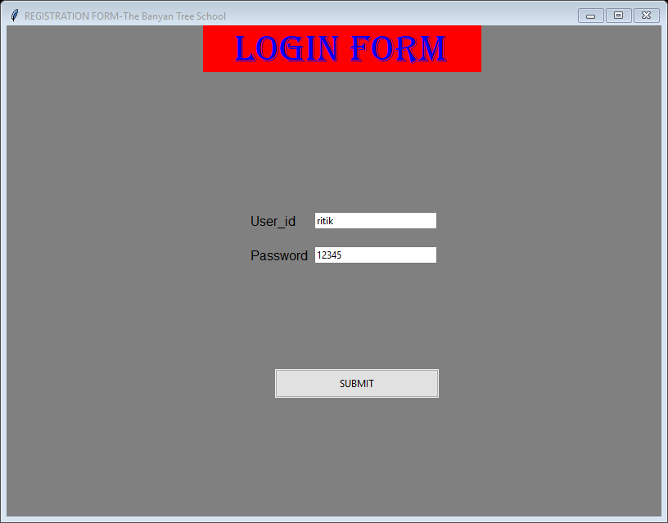

**import** mysql.connector **as** sq  
**from** tkinter **import *  
from** tkinter.ttk **import *  
import** tkinter.messagebox  
**from** subprocess **import** call  
  
os2**=**Tk**()**os2.title**("REGISTRATION FORM-The Banyan Tree School")**os2.geometry**('800x500')**os2.maxsize**(**800,600**)**os2.minsize**(**800,600**)**os2.configure**(**background**="grey")**a1**=**StringVar**()**b1**=**StringVar**()**head1**=**Label**(**os2,text**=" LOGIN FORM"**, background**="RED"**, font**="algerian 35"**, foreground**="BLUE"**,width**=**12**)**head1.place**(**relx**=**0.30**)**a **=** Label**(**os2,text**="User_id"**, width**=**35, background**="grey"**,font**="bold")**.place**(**relx**=**0.37,rely**=**0.38**)**Entry**(**os2,textvariable**=**a1**)**.place**(**relx**=**0.47,rely**=**0.38,width**=**150**)**b **=** Label**(**os2,text**="Password"**, width**=**35, background**="grey"**,font**="bold")**.place**(**relx**=**0.37,rely**=**0.45**)**Entry**(**os2,textvariable**=**b1**)**.place**(**relx**=**0.47,rely**=**0.45,width**=**150**)  
  
def lgn():** mycon **=** sq.connect**(**host**="localhost"**,database**="project"**,user**="root"**,passwd**="root")** cur **=** mycon.cursor**()  
 if (**a1.get**()=='ritik' and** b1.get**()=='12345'):** call**(["python"**, **"update.py"])  
 else:** tkinter.messagebox.showinfo**("Try again"**,**"user id or password is incorrect")**d **=** Button**(**os2, text**="SUBMIT"**, command**=**lgn**)**d.place**(**relx**=**0.41,rely**=**0.70,height**=**35,width**=**200**)**os2.mainloop**()**

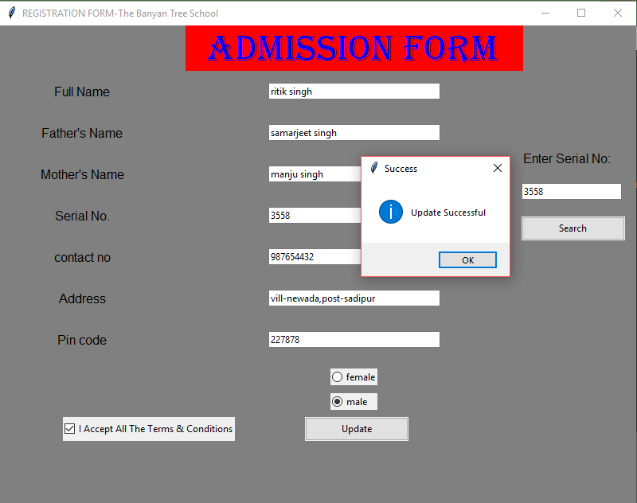

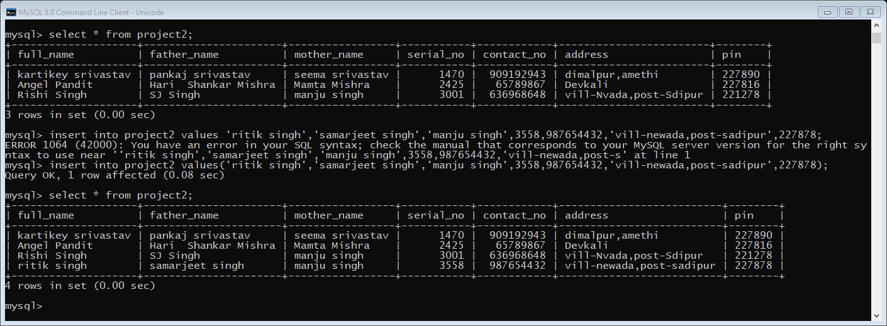

**from** tkinter **import *  
from** tkinter.ttk **import *  
from** subprocess **import** call  
**import** mysql.connector **as** sqltor  
**from** tkinter **import** messagebox  
  
os**=**Tk**()**os.title**("REGISTRATION FORM-The Banyan Tree School")**os.geometry**("800x500")**os.configure**(**background**="grey")**os.maxsize**(**800,600**)**os.minsize**(**800,600**)**f_name **=** StringVar**()**fs_name**=**StringVar**()**ms_name**=**StringVar**()**sr_no**=**StringVar**()**con_no**=**StringVar**()**add**=**StringVar**()**pin**=**StringVar**()**srn**=**StringVar**()  
  
def call():** mycon**=**sqltor.connect**(**host**="localhost"**,user**="root"**,passwd**="root"**,database**="project")** cur**=**mycon.cursor**()** cur.execute**("select * from project2 where serial_no = '"+**srn.get**()+"'")** data **=** cur.fetchall**()** f_name.set**(**data**[**0**][**0**])** fs_name.set**(**data**[**0**][**1**])** ms_name.set**(**data**[**0**][**2**])** sr_no.set**(**data**[**0**][**3**])** con_no.set**(**data**[**0**][**4**])** add.set**(**data**[**0**][**5**])** pin.set**(**data**[**0**][**6**])**label1**=**Label**(**os,text**=" Admission form"**,background**="RED"**,width**="15"**,font**="algerian 35"**,foreground**="BLUE")**label2**=**Label**(**os,text**="Full Name"**,background**="grey"**,foreground**='black'**,font**="bold")**label3**=**Label**(**os,text**="Father's Name"**,background**='grey'**,foreground**='black'**,font**="bold")**label4**=**Label**(**os,text**="Mother's Name"**,background**='grey'**,foreground**='black'**,font**="bold")**label5**=**Label**(**os,text**="Serial No."**,background**='grey'**,foreground**='black'**,font**="bold")**label6**=**Label**(**os,text**="contact no"**,background**="grey"**,foreground**='black'**,font**="bold")**label7**=**Label**(**os,text**="Address"**,background**="grey"**,foreground**='black'**,font**="bold")**label8**=**Label**(**os,text**="Pin code"**,background**="grey"**,foreground**='black'**,font**="bold")**label9**=**Label**(**os,text**="Enter Serial No:"**,background**="grey"**,foreground**='black'**,font**="bold")**bu1 **=**Checkbutton**(**os,text**="I Accept All The Terms & Conditions")**bu2 **=**Button**(**os,text**="Search"**,command**=**call,width**="20")  
def update():** mycon**=**sqltor.connect**(**host**="localhost"**,user**="root"**,passwd**="root"**,database**="project")** cur**=**mycon.cursor**()** cur.execute**("update project2 set full_name='" +**f_name.get**()+ "',father_name='" +**fs_name.get**()+ "',mother_name='" +**ms_name.get**()+ "',serial_no='" +**sr_no.get**()+ "',contact_no='" +**con_no.get**()+ "',address='" +**add.get**()+ "',pin='" +**pin.get**()+ "' where serial_no='" +**srn.get**()+ "'")** mycon.commit**()** mycon.close**()** messagebox.showinfo**("Success"**, **"Update Successful")**bu3 **=**Button**(**os,text**="Update"**,command**=**update,width**="20")**gen1**=**Radiobutton**(**os,text**='female'**,value**=**1,width**="6")**gen2**=**Radiobutton**(**os,text**='male'**,value**=**2,width**="6")**user2**=**Entry**(**os,width**="35"**,textvariable**=**f_name**)**user3**=**Entry**(**os,width**="35"**,textvariable**=**fs_name**)**user4**=**Entry**(**os,width**="35"**,textvariable**=**ms_name**)**user5**=**Entry**(**os,width**="35"**,textvariable**=**sr_no**)**user6**=**Entry**(**os,width**="35"**,textvariable**=**con_no**)**user7**=**Entry**(**os,width**="35"**,textvariable**=**add**)**user8**=**Entry**(**os,width**="35"**,textvariable**=**pin**)**user9**=**Entry**(**os,width**="20"**,textvariable**=**srn**)**label1.grid**(**row**=**0,column**=**1,pady**=**0,padx**=**25**)**label2.grid**(**row**=**1,column**=**0,pady**=**15,padx**=**25**)**label3.grid**(**row**=**2,column**=**0,pady**=**15,padx**=**50**)**label4.grid**(**row**=**3,column**=**0,pady**=**15,padx**=**50**)**label5.grid**(**row**=**4,column**=**0,pady**=**15,padx**=**50**)**label6.grid**(**row**=**5,column**=**0,pady**=**15,padx**=**50**)**label7.grid**(**row**=**6,column**=**0,pady**=**15,padx**=**50**)**label8.grid**(**row**=**7,column**=**0,pady**=**15,padx**=**50**)**label9.place**(**relx**=**0.82,rely**=**0.26**)**bu1.place**(**relx**=**0.10,rely**=**0.82,height**=**30**)**bu2.place**(**relx**=**0.82,rely**=**0.40,height**=**30**)**bu3.place**(**relx**=**0.48,rely**=**0.82,height**=**30**)**gen1.grid**(**row**=**9,column**=**1,pady**=**10**)**gen2.grid**(**row**=**10,column**=**1**)**user2.grid**(**row**=**1,column**=**1**)**user3.grid**(**row**=**2,column**=**1**)**user4.grid**(**row**=**3,column**=**1**)**user5.grid**(**row**=**4,column**=**1**)**user6.grid**(**row**=**5,column**=**1**)**user7.grid**(**row**=**6,column**=**1**)**user8.grid**(**row**=**7,column**=**1**)**user9.place**(**relx**=**0.82,rely**=**0.33**)**os.mainloop**()**